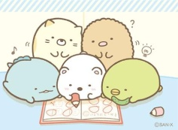
Big English 2 – Unit 2

- Vocabulary
- Activity
play basketball | kick a soccer ball  (play soccer) | hit a baseball  (play baseball) | play on the slide
jump rope | skate | skateboard | ride a bike
play hide-and-seek | draw | throw | hop

- Prepositions of place and direction
between | behind | in front of | next to

- Numbers
ten | twenty | thirty | forty | fifty
sixty | seventy | eighty | ninety | one hundred

- Country (*)
India | Guatemala | South Korea

- Noun (*)
seesaw | skateboard | slide | swing
video games | foot / feet | bone | muscle

- Grammar
- Do / Does
I / you/ we /they | He/she/it/name
Do | Does

- Like to do
What does he/she like to do? | He / She likes to skate.
What do they like to do? | They like to fly kites.

